Group No

List of members

Arsh

Customise this document - make this cover your own design

Contents

Executive Summary 2

Design Analysis Process 2

Entity Relationship Diagram 3

Table Designs – Data Dictionary 4

Contributions 5

References 5

# Executive Summary

**In a nutshell, summarise your system**.

# Design Analysis Process

**You may add the evidence of all the analysis tasks you carried out with sufficient explanations and justifications (Ex- User stories, use cases, use case diagrams, actors, functional and non-functional requirements, evidence from brainstorming). Add sub topics/sections appropriately.**

What you did. Why you did it. Why is your implementation better. Your final system is probably different from your proposal – why?

Spend some time thinking about why you made the design choices that you did - there is no wrong answer here

List your use cases – these are implemented as queries in your system. **You need many (at least 12) -**

* Use case 1
* Use Case 2
* Use Case 3
* Etc…

# Entity Relationship Diagram

**You can add logical and physical ERD design (at least 5-6 entities) of your system here. Also briefly explain the relationships with cardinalities between entities in words.**

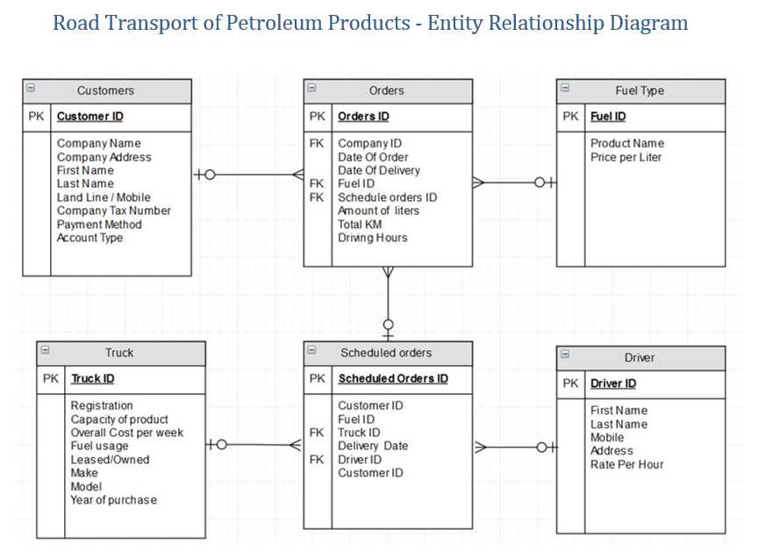

# Table Designs – Data Dictionary

**Add** **your data dictionary here (table structure for each table in your database)**

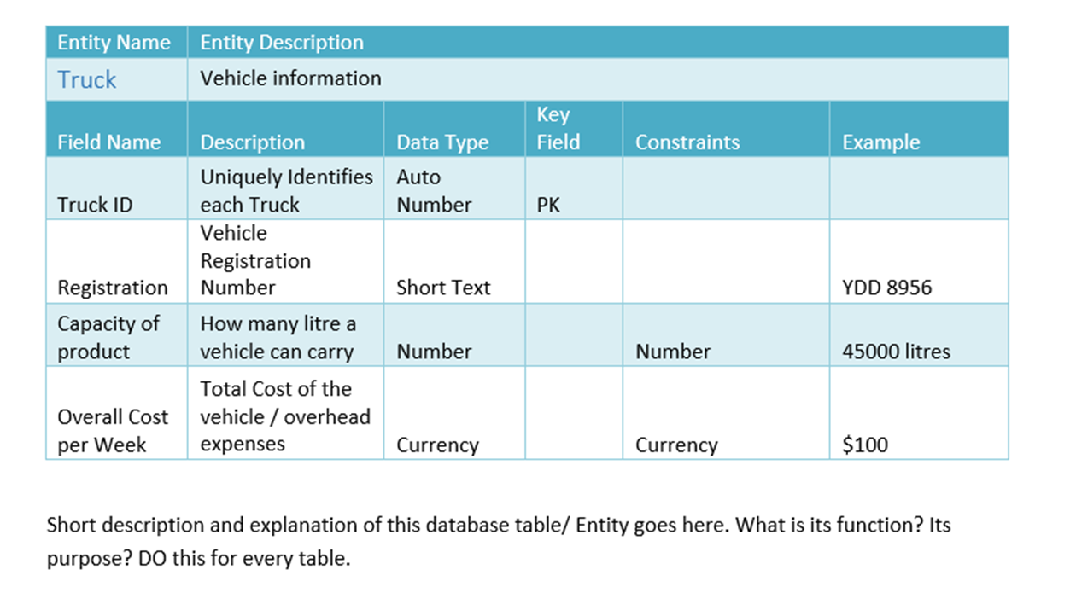







# Contributions

Add the list of members and their contributions to the project.

Also add the link to your GitHub Repository

# References

Add references here if you have any.